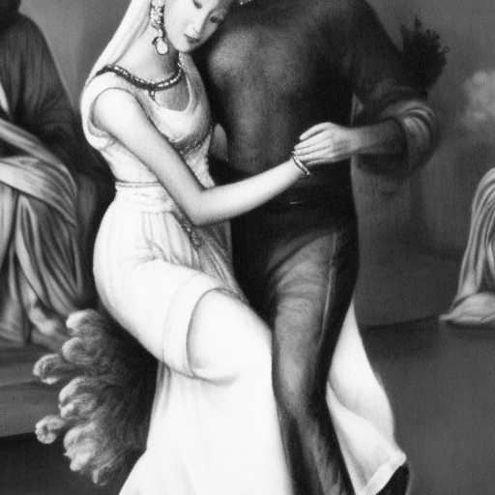
WISDOM TRIPARTITE

A Divine Woman is guided by Wisdom, Who helps her meet her husband with each Divine role, as appropriate
to guarantee his lasting, loving commitment

In the first case she is a superior
In the second, an equal
And in the third, an inferior
Her husband is as well
Let not the dance be about power
May it be about Beauty

